Templates for

Control Medi Easy

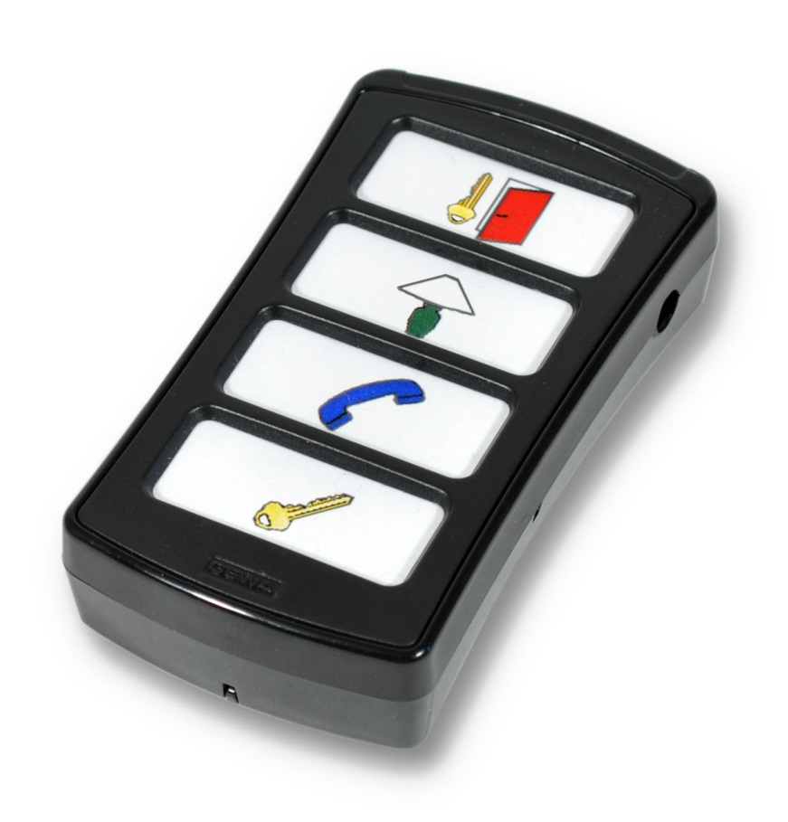

Templates

1
AAAAAAAAAAAAAAAAAAAA

2
AAAAAAAAAAAAAAAAAAAA

3
AAAAAAAAAAAAAAAAAAAA

!
!

AAAAAAA

AAAAAAA

AAAAAA

!

Make your own overlay!
Create your own text or use enclosed pictures. Following pages contains 400 pictures.

BED
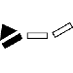
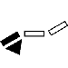
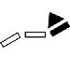

DVD

HIFI
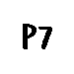

NUMBERS

SYMBOLS
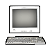
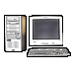
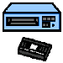
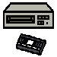
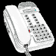
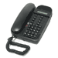
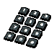
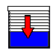
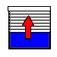
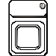
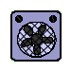
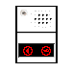
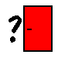

PICTOGRAM

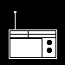

TELEPHONE
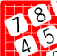
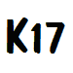
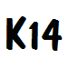
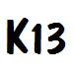
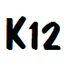
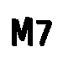
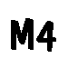

TV
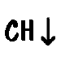

VCR

Doc: Overlay Design Control Medi Easy, A4, Ver: A. Date: 2013-08-21.

Abilia AB, Kung Hans väg 3, Sollentuna, Box 92, 191 22 Sollentuna, Sweden
Phone +46 (0)8-594 694 00 | Fax +46 (0)8-594 694 19 | info@abilia.se | www.abilia.se

