Templates for

Control Medi Multi and Control Medi Standard

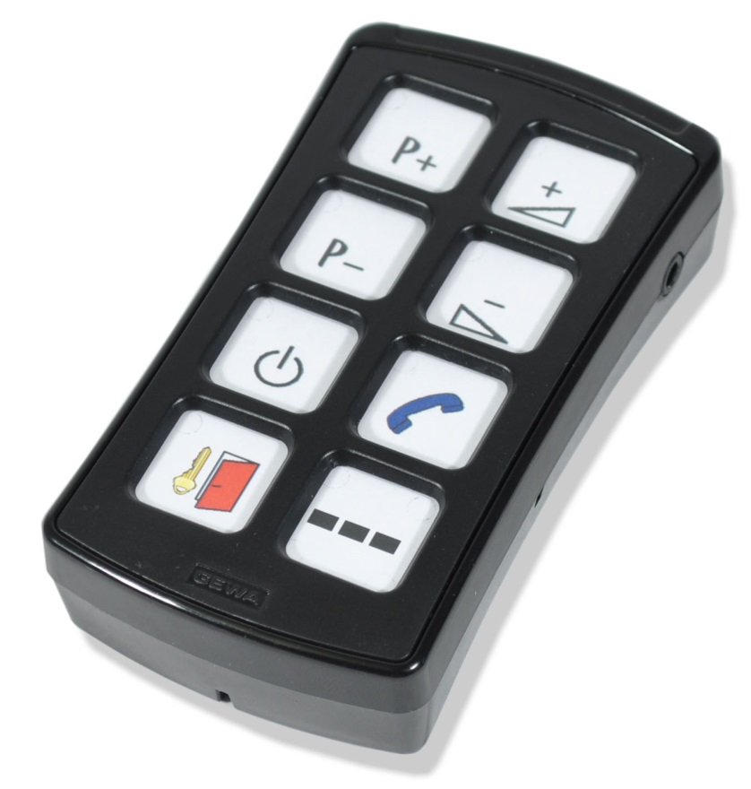

Templates

AAAA
BBBB
CCCC

!
AAAA
BBBB
CCCC

AAAA
BBBB
CCCC

AAAA
BBBB
CCCC

AAAA
BBBB
CCCC

1
2

4
3
AAAA
BBBB
CCCC

5
6

!

AAAAAA
AAAAAA
AAAAAA
AAAAAA
AAAAAA
AAAAAA
AAAAAA

AAAAAA

Make your own overlay!
Create your own text or use enclosed pictures. Following pages contains 400 pictures.

BED
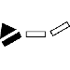
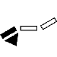
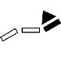

DVD

HIFI

NUMBERS

SYMBOLS
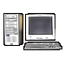
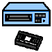
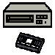
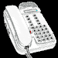
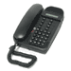
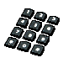
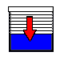
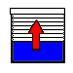
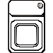
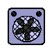
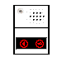

PICTOGRAM

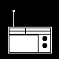

TELEPHONE
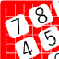
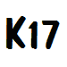
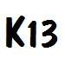
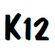

TV

VCR

Doc: Overlay Design Control Medi Multi_Standard , A4, Ver: A. Date: 2013-08-20.

Abilia AB, Kung Hans väg 3, Sollentuna, Box 92, 191 22 Sollentuna, Sweden
Phone +46 (0)8-594 694 00 | Fax +46 (0)8-594 694 19 | info@abilia.se | www.abilia.se

